📘 WEATHER APPLICATION
Web-Based Weather Forecast Project

Submitted by:
Dhanalakshmi konduru
Role: Full Stack java Developer
Technologies: JavaScript, HTML, CSS, OpenWeatherMap API

🟦 1. Project Overview
The Weather Application is a responsive web application that fetches real-time weather data from a public API and displays it in a user-friendly interface. It emphasizes API integration, interactive UI, unit conversion, and responsive design. Users can search for cities, view current weather, and check a 5-day forecast.

🟦 2. Project Description
A JavaScript-based web application that allows users to:
- View current weather conditions (temperature, humidity, wind, description)
- Check a 5-day weather forecast with day/night temperatures
- Search for cities with autocomplete suggestions
- Toggle between Celsius and Fahrenheit
- Save favorite cities for quick access
- Handle errors and display loading states
Data is fetched from the OpenWeatherMap API, ensuring real-time accuracy.

🟦 3. Project Objectives
- Build a functional weather application using JavaScript, HTML, and CSS
- Integrate OpenWeatherMap API for real-time data
- Implement city search with autocomplete
- Allow temperature unit conversion (Celsius ↔ Fahrenheit)
- Store favorite cities in browser localStorage
- Ensure responsive design across devices
- Handle errors and loading states gracefully

🟦 4. Features
- Display current weather for searched cities
- 5-day weather forecast
- Search cities with autocomplete suggestions
- Celsius/Fahrenheit conversion toggle
- Save and view favorite cities
- Loading indicators and error messages
- Responsive design for mobile, tablet, and desktop

🟦 5. Technologies Used
- JavaScript – Frontend logic and API calls
- HTML/CSS – UI structure and styling
- OpenWeatherMap API – Fetch current weather and forecast
- LocalStorage – Save favorite cities
- Responsive Design – Media queries and flexible layout
- Error Handling – Handle invalid input and API errors

🟦 6. Setup and Installation Instructions
- Register at OpenWeatherMap to obtain an API key.
- Clone the repository:
- git clone <repository-url>
- cd weather-app
- Copy .env.example to .env and add your API key:
- API_KEY=your_openweathermap_api_key
- Open index.html in your browser, or deploy the project to GitHub Pages.

🟦 7. Code Structure Explanation
File / Folder | Description
index.html | Main HTML page with layout and UI elements
style.css | Styling for responsive design and layout
script.js | Main JavaScript file handling API calls, search, unit conversion, and DOM updates
components/WeatherCard.js | Component to display current weather
components/Forecast.js | Component to display 5-day forecast
components/Search.js | Autocomplete search component
utils/api.js | Functions for fetching data from OpenWeatherMap API
utils/helpers.js | Utility functions (unit conversion, date formatting)
assets/icons/ | Weather icons for display
.env.example | Template for API key

🟦 8. Component Hierarchy
App
├── SearchBar
│ └── AutocompleteList
├── CurrentWeatherCard
├── ForecastContainer
│ ├── ForecastCard (x5)
├── FavoritesList
└── UnitToggle
Explanation:
- SearchBar: Handles user input and autocomplete.
- CurrentWeatherCard: Displays real-time weather details.
- ForecastContainer: Shows 5-day forecast with daily cards.
- FavoritesList: Stores and displays saved favorite cities.
- UnitToggle: Switches temperature units.

🟦 9. How to Use
- Open the application in a browser.
- Use the search bar to type a city name; select from autocomplete suggestions.
- View current weather and 5-day forecast for the selected city.
- Use unit toggle to switch between Celsius and Fahrenheit.
- Add cities to favorites for quick access.
- The app automatically handles loading states and shows errors for invalid cities.

🟦 10. Key Technical Requirements Met
- Real-time data fetched from OpenWeatherMap API
- Display of current weather and 5-day forecast
- City search with autocomplete functionality
- Celsius/Fahrenheit conversion toggle
- Favorite city storage using localStorage
- Responsive design for desktop, tablet, and mobile
- Error handling and loading states implemented

🟦 11. Screenshots of Working Application
- Seach the city name

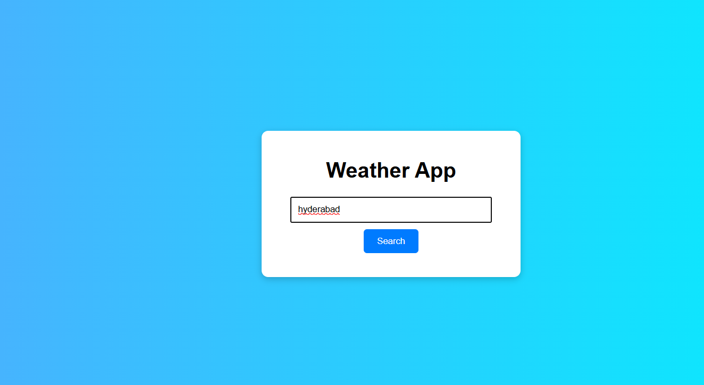
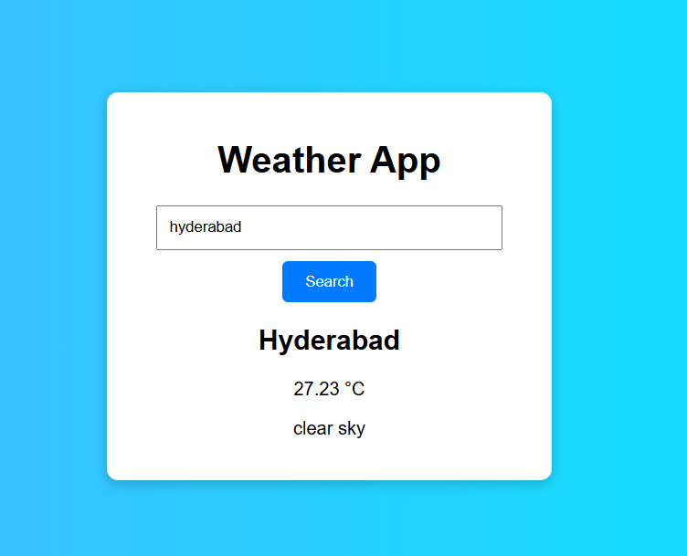

🟦 12. Conclusion
This project demonstrates a functional, user-friendly weather application with API integration, unit conversion, search with autocomplete, and responsive design. It meets all technical requirements while providing a smooth and interactive experience for user

